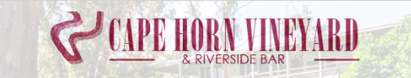

**DRINKS MENU**

**BEER:**

James Boag Light **$7**

Great Northern **$8**

VB

Carlton Draught

Carlton Dry

Corona

Millers Chill

Yenda Pale Ale

**\*\* Wine as per Wine List\*\***

**MIXERS:**

Canadian Club Dry **$10**

Canadian Club Coke

Jim Beam Coke

Bundaberg Rum & Coke

Smirnoff Ice Lemon

Cruisers – Lemon & Lime, Pineapple & Raspberry

**CIDERS:**

Bulmers **$10**

Cheeky Cider Apple

**NON-ALCOHLIC:**

Cascade Lemon, Lime & Bitters, Soda Water **$3**

Mt Franklin Sparkling Water

Coke, Coke No Sugar, Fanta, Lift & Sprite **$3**